**İLK SPRİNT KANITLARI**

* **03.06.2023**

* **05.06.2023**

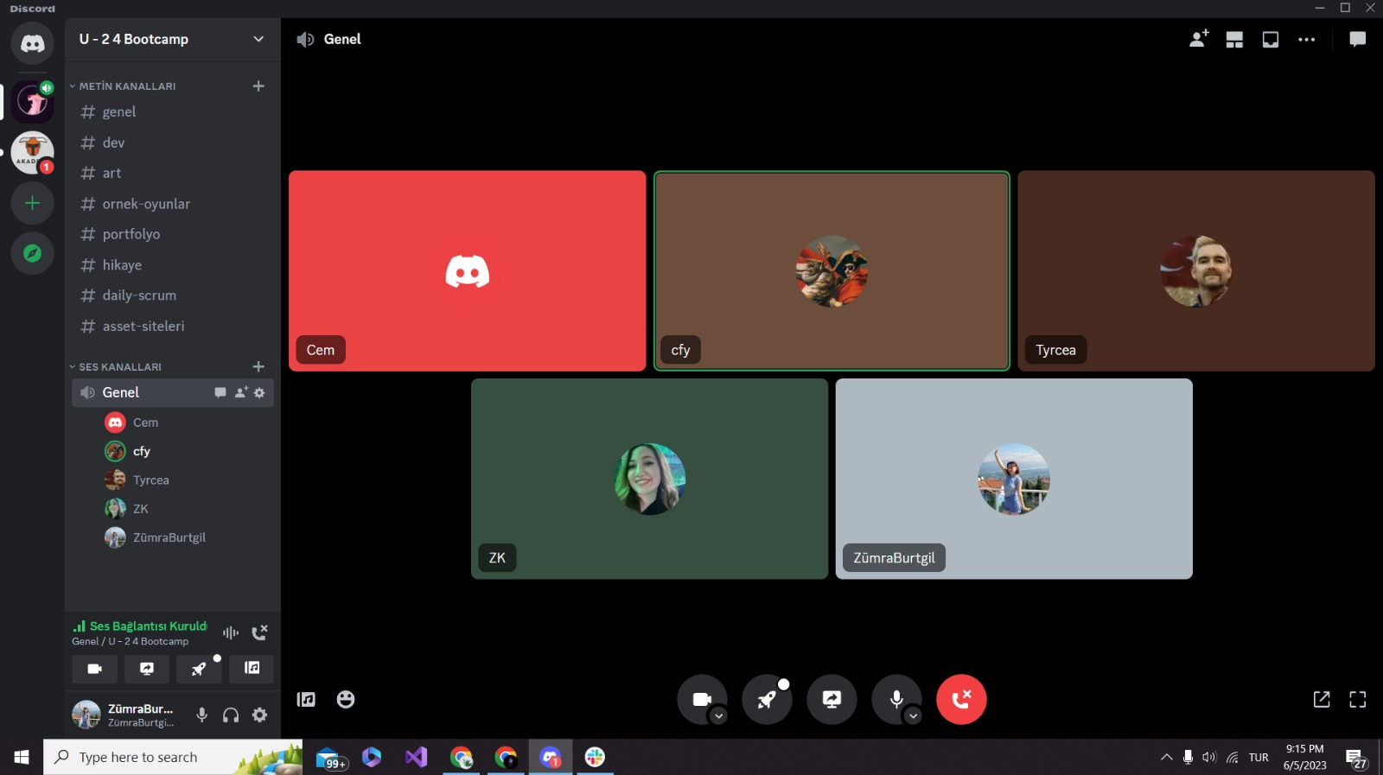

* **06.06.2023**

**(Toplantı notlarımız)**

* **07.06.2023**

**(En başta game artistimizin çalışmalarına öncelik verdik.)**

* **08.06.2023**

**(Game artistimizin devam eden çalışmaları ve toplantı notlarımız)**

* **09.06.2023**

* **10.06.2023**

**(Game artistimizin ilk level için çalışmaları biterken level designerımız map çalışmalarına başladı)**

* **11.06.2023**

* **12.06.2023**

* **13.06.2023**



* **14.06.2023**

* **15.06.2023**

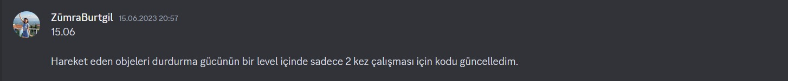

* **16.06.2023**

* **17.06.2023**

* **18.06.2023**

